ZONING BOARD OF ADJUSTMENT MEETING
DECEMBER 13, 2023
A G E N D A

A. Call to Order
- Salute to Flag
- Roll Call

B. Old Business
- Continued and Hold Over Applications

CONTINUED APPLICATION(S)
Case No. | Applicant | Location | Application | Complete | Time To Act
CARRY OVER APPLICATION(S)
Case No. | Applicant | Location | Application | Complete | Time To Act

C. New Business
- December Application(s)

Case No. | Applicant | Location | Application | Complete | Time To Act
23-24  23-25  23-26 | Emily Golembieski  John/Amanda Towlen  David/Sherry Kuo | 60 Karcher St.  11 Kierst St.  3275 Washington Rd. | Bulk Variance/Additions  1st and 2nd floors  Bulk Variance/Garage  Addition  Bulk Variance/Fence | November 22, 2023  November 22, 2023  November 29, 2023 | March 21, 2024  March 21, 2024  March 28, 2024

D. Public Comment (on issues not relating to present or pending Applications or litigation)

Case No. | Applicant | Location | Application | Complete | Heard

F. Approval/Acceptance of Regular Meeting Minutes
- October 25, 2023

G. Adjournment
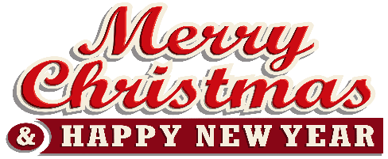
This Photo by Unknown Author is licensed under CC BY-NC
This Photo by Unknown Author is licensed under CC BY-NC

